Name: ______Mary Oh______

Student ID: ______1208315416____  
Date: _____04.29.18______

**Instructions:** Congratulations, you made it to the end of the course! You should have at least seven pages of your site completed by the time you submit this. Use the following to have a written discussion about your experience in the course and the final project.

**Before submitting this document and all of your project files, make sure you meet all of these requirements:**

* You have complete the “Final Submission and Discussion” worksheet.
* You have zipped up or compressed your final project folder (including all of your HTML, CSS, images, videos, etc.)
* All the requirements listed in the CIS300 Project Instructions.pdf file.
* Make sure you include all the required screenshots listed in this file. 2 points will be taken off for each missing screenshot.

**Discussion Questions**

1. **Now that you are finished with your project, your original concept of your project might have changed a lot. Discuss in detail the differences between your initial project design and your final product. Why did you make these changes (if you had any)?**  
     
   The only change I had was about the doctor’s access page as the monitoring system was not able to achieve the final goal. I did however, did a mock downloadable report.
2. **Describe in detail why you chose the design layout you did. Are you happy with the outcome? Did you run into any issues with your design while developing your site? What did you do to overcome those issues? Would you do anything differently the next time you designed a website?**   
     
   I am happy with the layout as I want it to be really simple. Since it is mostly scientific information, I want the whole website to feel light and nothing too heavy on designs and the like.
3. **You likely encountered challenges while working on your final project. In detail, describe the challenges you encountered and what you did to overcome them.**   
     
   The main challenge is having to have information to put on the website. Since this is about another project, until that is finish, then I wouldn’t have much information for this website.
4. **Describe several concepts that you learned during this course that you found interesting and useful. Where there any concepts that you wish more time was spent on? Is there anything you would have like to incorporate into your final project that wasn’t covered during this course?**  
     
   I was hoping to learn more about the jquery. I think that would’ve been really helpful.
5. **OPTIONAL (NOT REQUIRED FOR THE CLASS OR FACTORED INTO YOUR GRADE): If you took advantage of the “Getting Online” video in the Week 6 / Chapter 12 folder and setup a domain and hosting, what were your thoughts on the process? Did you run into any issues? What domain did you pick? Did you upload your files? You may have already answered this in the update #2, but some students wait until the end to complete this.**
6. **While trying to be as objective and unbiased as possible, please go through and critique your own site using the attached rubric. In the student critique column, indicate which score you should receive for each category (outstanding, average, or needs improvement) and write a short (1 or two sentence max) justification of that score.**

**Student Critique**

|  |  |  |  |  |
| --- | --- | --- | --- | --- |
|  | **Outstanding** | **Average** | **Needs Improvement** | **Student Critique** |
| **EXAMPLE** | You did everything! | You did a few things. | You did nothing… | Outstanding – I believe I did everything correctly because of x, y, and z. |
| **Discussion Questions 1-4: Answers** | Clearly and completely answered the questions. Organized, neat in appearance, easy to read and understand | Answers to questions could have been more complete or clear. The document is not easy to read or understand | Answers were missing. | Outstanding – I believe I clearly and completely answered the questions. |
| **Discussion Question 6: Mechanics** | Clearly and completely answered the questions. Organized, neat in appearance, easy to read and understand. | Answers to questions could have been more complete or clear. | Answers were missing. | Outstanding – I believe even if the page is facts and scientific heavy, it still doesn’t feel overwhelming. |
| **Visual Appeal**  appealing to target audience | 1. Use of color, contrast, text, and graphics. 2. Navigation is consistent. 3. Page titles and logo are descriptive. 4. E-mail link is presented. | Not appealing to target audience in one area; Image based page (where the page contains little or no text or content other than images) | Not appealing to target audience in more than one area; missing or does not include | Outstanding – the page I believe is very simple and nothing too cluttered. |
| **Accessibility and Validation** | W3C Guidelines followed; numbers of web pages; validated external CSS file | Two or fewer instances where W3C guidelines are not followed; less than required pages; External CSS file is present but does not pass validation | Three or more instances where W3C guidelines are not followed; External CSS file is not present or does not pass validation | Outstanding – CSS file is validated. |
| **Table** | Present and correct syntax | -- | Missing or incorrect syntax | Needs improvement – did not use any table |
| **Video** | Present and correct syntax, <video> tag is used | -- | Missing or incorrect syntax | Needs improvement – did not use video |
| **Outside Link** | Present and correct syntax | -- | Missing or incorrect syntax | Outstanding – I believe I have correct syntax |
| **Meta tag** | Correct syntax (description meta tags), excellent selection of keywords and meaningful description | Correct syntax (description meta tags), adequate selection of keywords and description | Missing or incorrect syntax | Outstanding – I believe I have correct syntax. |
| **Form Coding and Processing** | Contains 4 or more form fields, correct syntax, and meaningful form element names. Use # or the pacific.php as the action | Missing required 4 form fields, names of fields, don’t make sense, or incorrect syntax. | Missing or not configured correctly | Outstanding – I used correct syntax. |

**Screenshot of Home Page**

**Screenshot of Page #1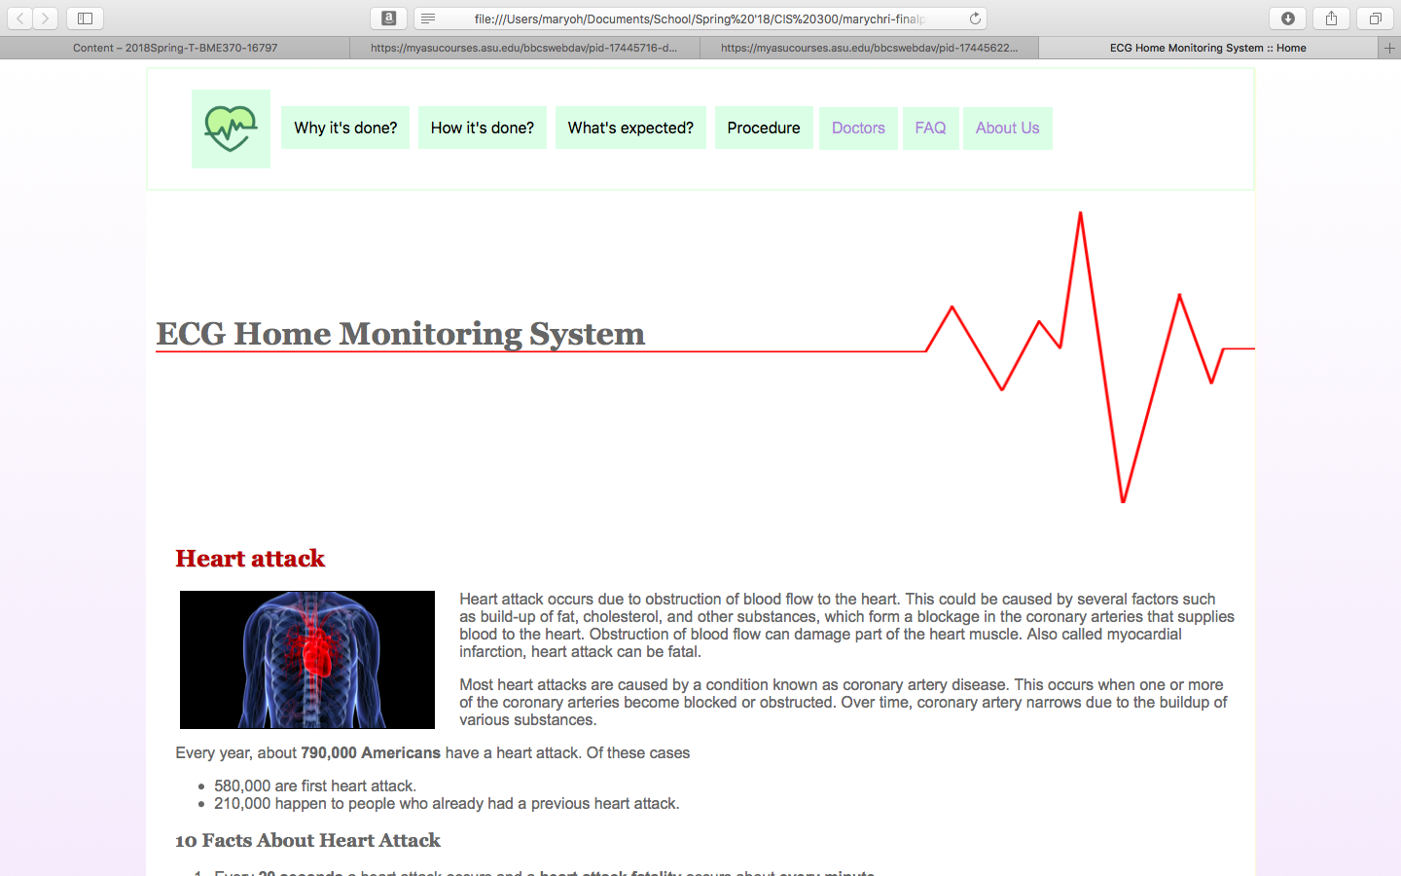  
Screenshot of Page #2**

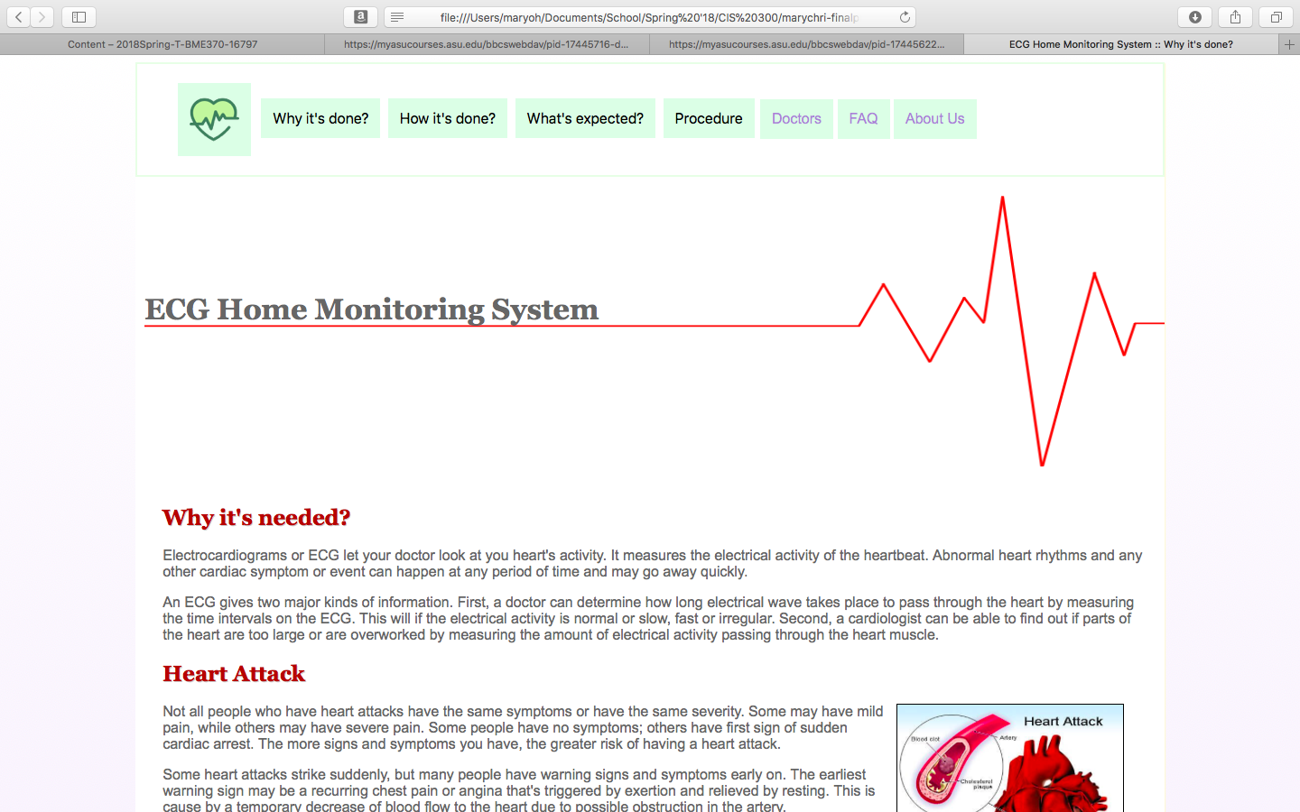

**Screenshot of Page #3**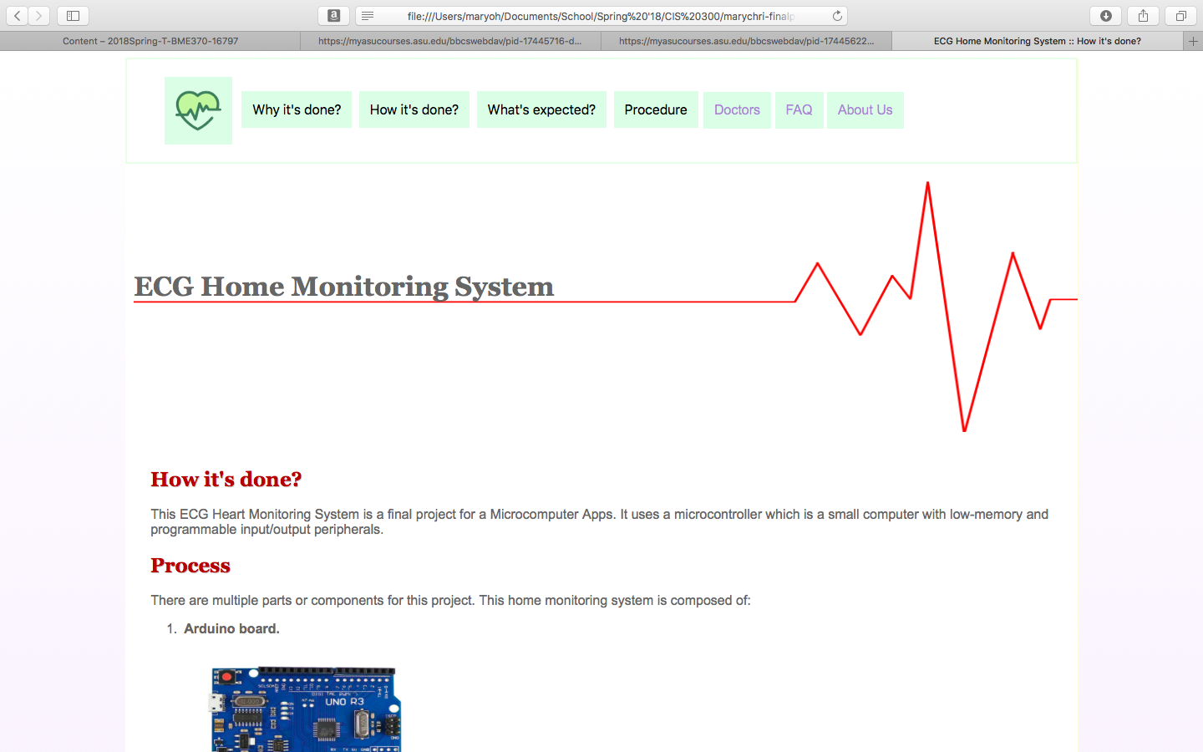

**Screenshot of Page #4**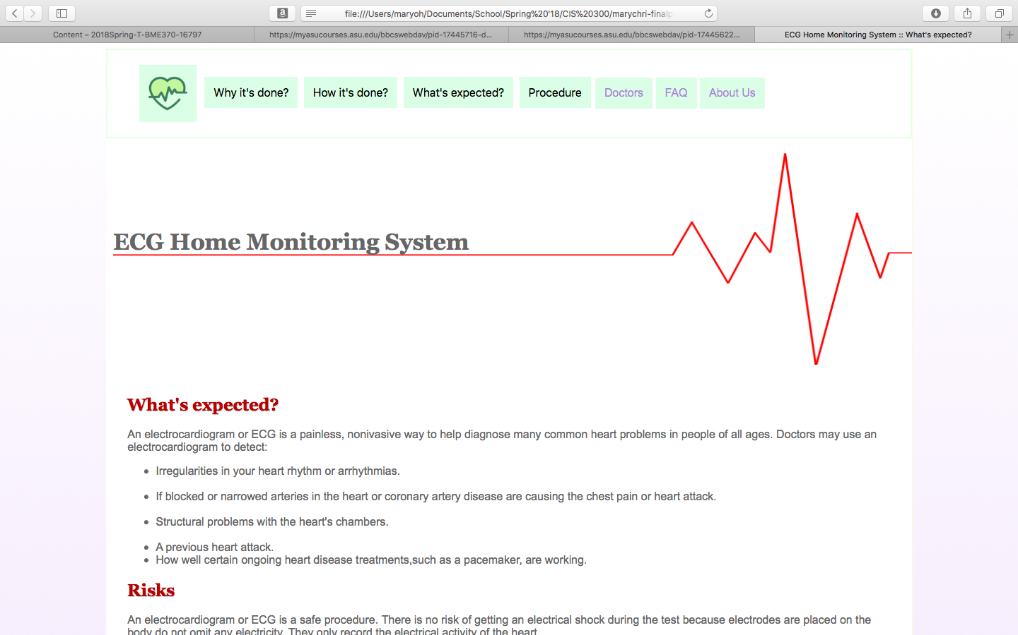

**Screenshot of Page #5**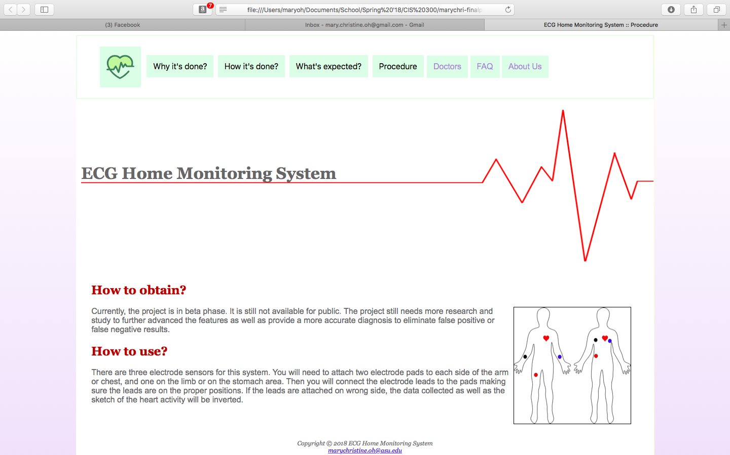

**Screenshot of Page #6**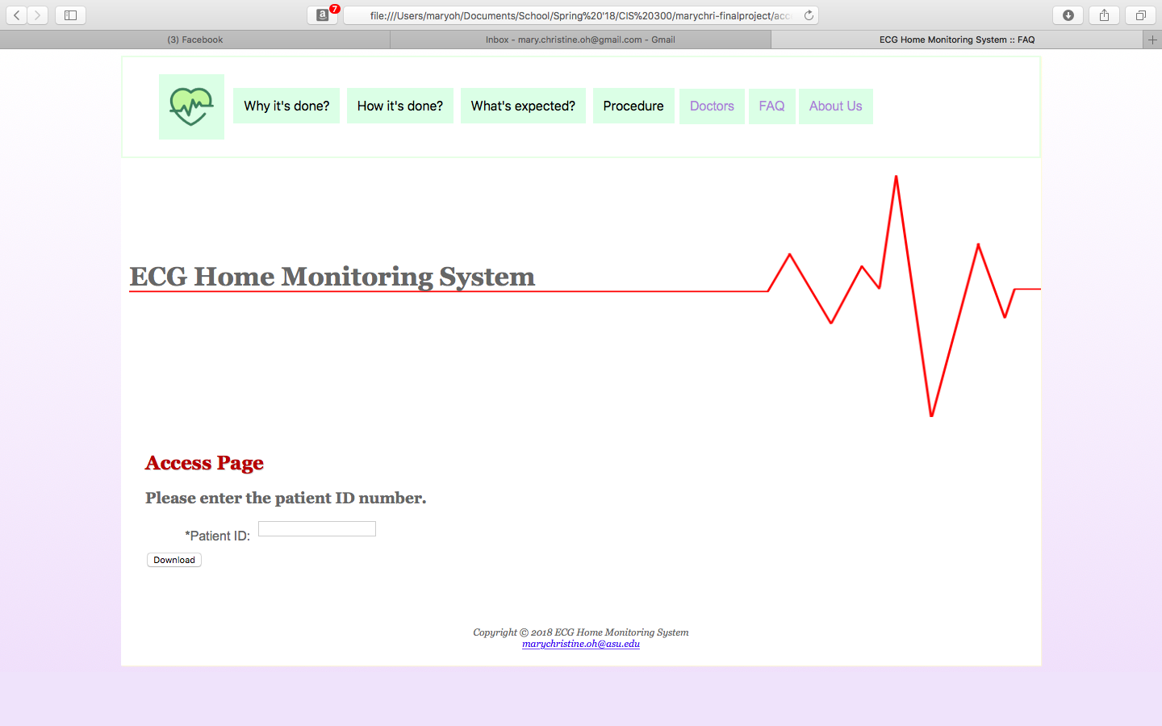

**Screenshot of location you used a table**

**Screenshot of where you used the <video> tag**

**Screenshot of where you used an e-mail link**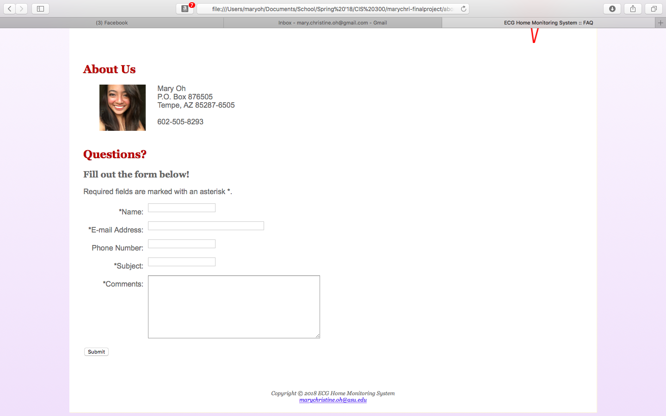

**Screenshot of where you used an external link**

**Screenshot of your form**

**READY TO SUBMIT? MAKE SURE YOU ZIP/COMPRESS YOUR WHOLE PROJECT FOLDER AND ATTACH BOTH THIS DOCUMENT AND YOUR PROJECT FOLDER.**